NOTICE OF ELECTION

Election of a Town Councillor

for the Town Ward listed below

Town Ward | Number of Town Councillor to be elected
Melksham (Melksham South Ward) | One

1 | Nomination papers must be hand delivered to the Returning Officer, or their appointed staff at Electoral Services, Wiltshire Council, County Hall, Bythesea Road, Trowbridge, Wiltshire, BA14 8JN on any day after the date of this notice, on working days from Monday to Friday 10am to 4pm (excluding bank holidays) but no later than 4pm on Friday 12 September 2025.
2 | Nomination papers may be obtained from the Returning Officer as follows:  - Online at www.electoralcommission.org.uk/guidance-candidates-parish-council-elections-england  - County Hall, Bythesea Road, Trowbridge, BA14 8JN  - The Council House, Bourne Hill, Salisbury SP1 3UZ  - Council Offices, Monkton Park, Chippenham SN15 1ER  Full details of the election can be found at https://elections.wiltshire.gov.uk/Home/Upcoming/None
3 | If any election is contested the poll will take place on Thursday 9 October 2025.
4 | Applications to register to vote must reach the Electoral Registration Officer by 12 midnight on Tuesday 23 September 2025. Applications can be made online at www.gov.uk/register-to-vote.
5 | Applications, amendments or cancellations of postal votes and amendments or cancellations of proxy votes must reach the Electoral Registration Officer by 5pm on Wednesday 24th September 2025. Applications can be made online at www.gov.uk/apply-postal-vote
6 | Applications for a Voter Authority Certificate or an Anonymous Elector’s Document valid for this election must reach the Electoral Registration Officer by 5pm on Wednesday 1 October 2025. Applications can be made online at www.gov.uk/apply-for-photo-id-voter-authority-certificate.
7 | New applications to vote by proxy at this election must reach the Electoral Registration Officer by 5pm on Wednesday 1 October 2025. Applications can be made online at www.gov.uk/apply-proxy-vote
8 | Applications to vote by emergency proxy at this election must reach the Electoral Registration Officer by 5pm on Thursday 9 October 2025
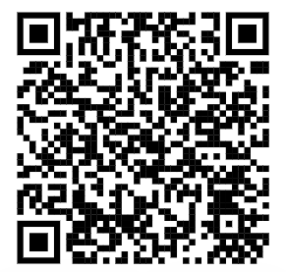
Full details of upcoming elections including timetables, nomination bookings, forms to register to vote and election results can be found by scanning the code. If you have any queries about this election contact Electoral Services at elections@wiltshire.gov.uk or call 0300 456 0112.

